**Group number: 2**

**PathSketch *Sheff-bot***

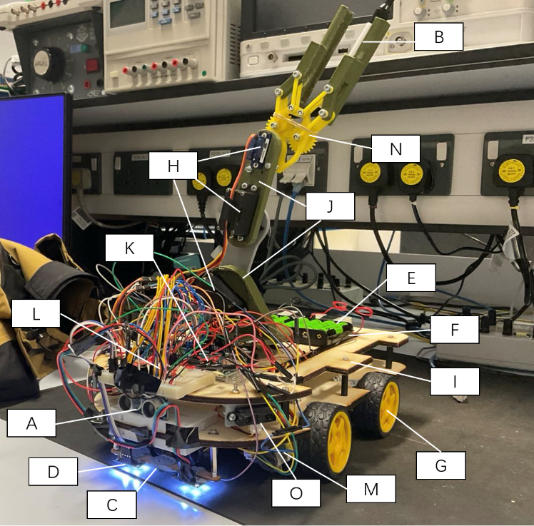Xirui Xu, Hanxiang Ji, Quang Hung Tran, Zeyang Zhuang, Rashid Ali Gandaman

**1 COMPONENT LIST & PURCHASED ITEMS**·Sensors and Electronic Components:HC-SR04 Ultrasonic Distance Sensor, SEN0101 Colour Sensor, E-SWITCH EG1218, L7805CV Voltage Regulator, L298N Motor Driver, Male Header Pins;

·Battery and Power Accessories: Rechargeable AA Battery, AA Cell Battery Holder for 4-cell Battery

·Motors and Mechanical Parts: Yellow Wheel for Geared Motor, DMS-MG90 Servo Motor, MG996R Servo Motor. Arduino and Development Platforms: Autonomous Robotics Platform - Line Follower Board, Arduino Mega.Tools and Accessories: JumperWires(SolidCore,AWG):Bolts/Nuts/Screws/Washers/Adhesives, Spacers, Brackets for Stability,

·Structural and Assembly Parts: Robotic arm(PLA), Chassis(Plywood),Gripper(Acrylic), Breadboard

**2 OUTSOURCED DESIGN/LIBRARY/SOFTWARE**

For the design of the chassis shape and the connection method between the DC motor and the chassis, we drew inspiration from the video available at [link1](https://www.youtube.com/watch?v=Ze4c_a3luqg). For the robotic arm design, we referred to the three-joint model depicted in the images from [link2](https://howtomechatronics.com/tutorials/arduino/diy-arduino-robot-arm-with-smartphone-control/). For the gripper's transmission mechanism, we took inspiration from the gear-driven mechanism shown in the video at [link3](https://www.youtube.com/watch?v=ZmckF8zYbp0&t=1450s) and redesigned it to fit the required whiteboard marker model, drawing partial inspiration from non-open-source references used only for visual or conceptual guidance. All modules, circuits, and code were independently developed by the team using Fusion 3D software.

**3 MECHANICAL DESIGN AND FABRICATION**

Most of the main components of the robot in Fig 1 have been labeled, except for the voltage regulator module connected to the power supply. This module functions to provide a stable voltage for the entire circuit system, preventing issues such as inconsistent wheel speed and sensor detection fluctuations caused by voltage variations.

Our design choices were always guided by the problem requirements. To meet the core needs of the task, including movement and steering, line-following, robotic arm rotation, and gripper actions (grasping and releasing), we modified and developed most of the parts accordingly. Fusion 360 was chosen to design for all parts of the robot.

One of the most important parts in the design is the chassis which connect the wheel, the arm and other

parts to perform the task well. In this project, after measuring the tunnel and the arena, the huge chassis with the size of 330 x 220 mm is cut by laser

Fig 1 The developed robot. A: HC-SR04 Ultrasonic distance sensor, B: Whiteboard Markers, C: Autonomous Robotics Platform - Line Follower Board, D: SEN0101 Colour Sensor, E: Rechargeable AA Battery, F: AA Cell Battery Holder for 4-cell Battery, G: Yellow Wheel for Geared Motor, H: servo motors, I: Plywood Chassis, J: 3D printer Robotic arm, K: Arduino Mega, L: Breadboard, M: DFRobot Accessories Micro DC Motor, N: Gripper, O: IR sensor

cutter method. Our intuition is to simulate bulky robots with a huge space to arrange diverse

components and add more functionality, but could still finish the task without difficulties in a small arena. We had a chance to make the chassis smaller and have a backup design, but our group remained the same size, and generally, it could finish the task without touching any walls.

·For movement and steering, we determined that a symmetric structure would be the most suitable to maintain the robot's center of gravity. Steering was achieved through differential wheel control, so we used four DC motors to drive four wheels, enabling independent control. However, the connector between the DC motor and the chassis is the huge challenge. After carefully calculating, we used four angle brackets to connect the four motors, ensuring their rigidity could support the entire chassis without breaking. Notably, since we pre-designed a voltage regulation circuit to mitigate the impact of voltage fluctuations on components, we did not require

encoders for wheel calibration. Using an ultrasonic distance sensor, the robot was able to accurately detect walls and execute precise turns

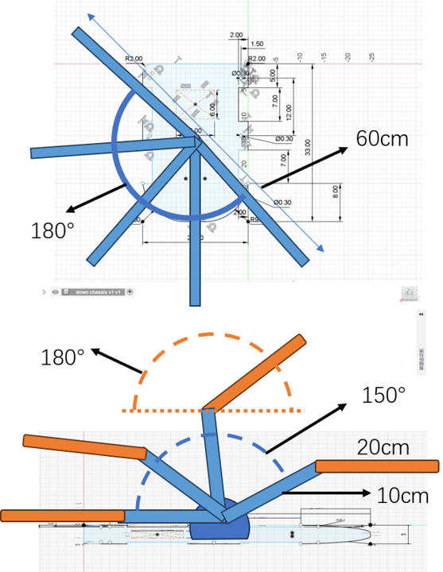

Fig 2 The workspace of the robot arm

·For line-following, we used the expensive Autonomous Robotics Platform - Line Follower Board at the front center for small deviation corrections The distance between the sensor and the ground is 10 mm, so that we connect it to a lower structure which could let the sensor perform work efficiently. To balance the impact of external light sources we decided to purchased two color sensors with LEDs to illuminate the center line sensor.

·For robotic arm rotation, given the height of our robot, it was necessary to fully lower the arm to safely pass through the field's tunnel. We designed a three-joint arm structure, with each joint controlled by a servo motor to allow a wide range of motion, as shown in Fig 2. The design meets the requirements for vertical wall drawing tasks. A servo motor connected to the chassis rotates the robotic arm's base around a central axis through base Rotation Joint, while two additional servo motors control the shoulder joint and elbow joint of the arm. This setup enables the arm to cover a hemispherical motion space. To protect the main circuit on the upper chassis, the shoulder joint's rotation angle is limited to 150 degrees in the code.

·For the gripper design, we employed a multi-gear transmission mechanism to tightly grip the whiteboard marker by increasing friction through pressure. However, we overlooked the fact that excessive friction prevented the marker from being

released in the final step, which led to a deduction in points.

·As for the Carriable load of the arm, The load is influenced by the two joints at the upper end of the robotic arm, based on the torque balance equation:

And the maximum load calculation formula:

we can determine that the maximum load of the robotic arm is approximately 154 grams which can stably support the weight of a whiteboard marker.

·For the overall process schedule, we finalized the design phase quickly, completing it within the planned week. For the manufacturing and testing process, we first installed the circuits to test the connections and evaluate the reliability of battery power, which took one week. After this, we went to iForge to 3D print the robotic arm. Due to a long queue, we utilized the waiting time to laser-cut the chassis and immediately assembled it for steering and line-following tests. Two weeks later, after receiving the robotic arm, we assembled it and began two weeks of overall testing, continuing until the day of the presentation.

·For the Stability (centre of mass location in the coordinates), we adopted a larger chassis with a symmetrical design to place various components of the robot. The battery pack was positioned at the rear to balance the weight of the sensors and circuit boards, while the robotic arm was installed at the center of the chassis to prevent changes in the center of mass from affecting the robot's movement during rotation. Calculations show that the center of mass remains near the center of the chassis at all times.

·In the process of fabricating the robot， We employed a 2D+3D hybrid technique for fabricating the robot. Laser cutting was used for the chassis, enabling efficient assembly and speeding up installation and debugging. The robotic arm, requiring a 3D structure, was 3D printed. For materials, we prioritized sustainability and budget. Acrylic scraps from iForge were laser-cut for the gripper, while a thick plywood board, chosen for its affordability and recyclability, was purchased and laser-cut to form the chassis.

·Regarding the types and specifications of the fabrication equipment and tools utilised. We used iForge's 3D printer and laser cutter. The 3D printer utilized a 0.2mm layer height and PLA material to fabricate the robotic arm. This layer height provided a good balance between precision and printing speed, making it suitable for the arm's complex structure. For the chassis and gripper, we used the laser cutter and compensated for the kerf during the design phase to ensure accurate part dimensions. To enhance sustainability, we optimized material utilization by adjusting the cutting layout and used recyclable PLA and scrap acrylic materials for fabrication.

**4 ELECTRONICS**

The Selection of Electronic Components:

For the Microcontrollers: The primary reason for choosing Arduino Mega is its abundant I/O interfaces, and highly expandable and easy to program, which is especially suitable for projects requiring multiple inputs/outputs, including multi-motor control, or multi-sensor data acquisition.

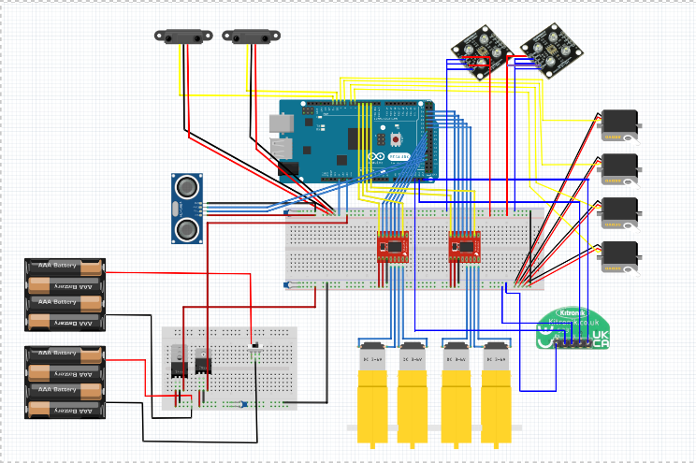

Fig 3 Schematic of the electronic circuit

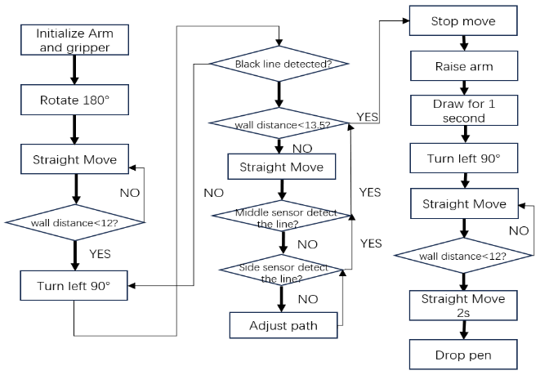·For the sensors, we chose the Ultrasonic Distance Sensor due to its precise distance measurement, which is used to detect wall distances for turning. The Line Follower Board was selected for line-following because its three onboard sensors can detect high return values from low-reflective surfaces (e.g.,>500 in black) and distinguish them from the very low return values of white surfaces(~100), making it effective for line-following logic. The Color Sensor was chosen because its built-in LED effectively mitigates the impact of external lighting, preventing changes in line-following return values that could affect the results.

·For the actuators, the four-wheel-drive design required us to use four DC motors for control. At the same time, to ensure the robotic arm could rotate within a sufficiently large range, we chose three MG996R servo motors for control. For the gripper, a lighter and more compact MG90 servo motor was used to prevent excessive shifts in the center of gravity. The gripper design utilizes a servo motor to drive a gear transmission mechanism, enabling it to grip or release objects.

Fig 4 Flowchart of the operational logic

·For the Batteries and robot’s operation time, we used a total of 8 AA batteries, providing a voltage of 9.6V. Through a voltage regulator circuit, the output voltage to the Arduino board is consistently maintained at 5V. Based on a power consumption of 48.705W, calculations show that the system can stably maintain a 5V output for approximately 29.6 minutes, which far exceeds the 10-minute demonstration requirement.

·For the Circuit board, wires, and connectors, we used a large number of male-to-female jumper wires for connections and applied waterproof tape between the wires to ensure the stability of the robot. Through proper distribution of the circuitry, we utilized two breadboards to accommodate two motor drivers and connect various sensors and circuit boards.

**5 CONTROL**

·The robot's control dynamics involve several stages. In the setup stage, the robotic arm rotates to a low angle to pass through a doorway, the gripper opens for holding a marker, and the wheels rotate 180 degrees. During the straight movement stage, the robot moves forward while the Ultrasonic Sensor monitors wall distance, transitioning to a left turn if below the threshold. In the left turn stage, the Line Follower Board detects a line, activating the line-following stage, where the robot adjusts its path and stops near the whiteboard. In the drawing stage, the arm draws for 1 second. Finally, the robot performs a 90-degree left turn, moves forward, and in the marker drop stage, releases the marker to complete the task.

·Let L1 represent the height of the base, and L2 and L3 represent the lengths of the links from the shoulder joint to the elbow joint and from the elbow joint to the end-effector, respectively. The base rotation angle about the vertical axis is denoted as θ1, while θ2 and θ3 represent the shoulder and elbow joint rotation angles about the horizontal axis. The coordinates of the end-effector are represented as XEE,YEE,ZEE.

Inverse Kinematics Equations:

**Appendix**

**Table 1: Mechanical and electronic components and material list**

|  |  |  |  |  |  |  |
| --- | --- | --- | --- | --- | --- | --- |
| component name/model | count | total weight | current/power consumption | total price excl. VAT | link | Labels in Fig.1 |
| HC-SR04 Ultrasonic distance sensor | 1 | 15g | 0.075W | £2.50 | [link](https://kitronik.co.uk/products/46130-ultrasonic-distance-sensor-hc-sr04-5v-version) | A |
| Whiteboard Marker | 1 | 10g | N/A | £0.12 | N/A | B |
| E-SWITCH EG1218 | 1 | 2g | N/A | £0.60 | N/A | not labelled |
| Autonomous Robotics Platform - Line Follower Board | 1 | 60g | 0.3W | £4.35 | [link](https://kitronik.co.uk/products/5337-autonomous-robotics-platform-line-follower-board) | C |
| L7805CV Voltage Regulator | 4 | 15g | 0.03W | £2.00 | [link](https://www.digikey.co.uk/en/products/detail/stmicroelectronics/L7805CV/585964?msockid=05760b2485ec6c9f2b1c1fa1848f6d23) | not labelled |
| SEN0101 Colour Sensor | 2 | 20g | 0.2W | £12.20 | [link](https://wiki.dfrobot.com/TCS3200_Color_Sensor__SKU_SEN0101_) | D |
| Rechargeable AA Battery | 8 | 240g | N/A | £16.00 | N/A | E |
| AA Cell Battery Holder for 4-cell Battery | 2 | 40g | N/A | £4.00 | N/A | F |
| Yellow Wheel for Geared Motor | 4 | 140g | N/A | £7.40 | [link](https://vle.shef.ac.uk/ultra/courses/_117982_1/cl/outline) | G |
| DMS-MG90 servo motor | 1 | 13.4g | 6W | (included in the kit) | N/A | H |
| MG996R servo motor | 3 | 165g | 18W | (included in the kit) | N/A | H |
| Plywood board for Chassis | 1 | 300g | N/A | £3.00 | [link](https://iforgesheffield.org/materials-prices/) | I |
| 3D print Robotic arm (consider in-fill percentage) | N/A | 375g | N/A | free from the iForge | N/A | J |
| Jumper wires (solid core, AWG) | N/A | ignorable | ignorable | (included in the kit) | N/A | not labelled |
| Bolts/nuts/screws/washers/adhesives | N/A | ignorable | N/A | (from the lab) | N/A | not labelled |
| Arduino Mega (Arduino Uno Swap) | 1 | 37g | 0.25W | (included in the kit) | N/A | K |
| Male header pins | N/A | ignorable | N/A | (from the lab) | N/A | not labelled |
| L298N motor driver | 2 | ignorable | 12W | (included in the kit) | N/A | not labelled |
| Spacers | N/A | ignorable | N/A | (from the lab) | N/A | not labelled |
| Breadboard | N/A | ignorable | N/A | (included in the kit) | N/A | L |
| Brackets for stability | 4 | ignorable | N/A | (from the lab) | N/A | not labelled |
| DFRobot Accessories Micro DC Motor | 4 | 20g | 12W | (included in the kit) | [link](https://vle.shef.ac.uk/ultra/courses/_117982_1/cl/outline) | M |
| Gripper | 1 |  | N/A | free from the iForge | N/A | N |
| IR sensor | 2 | 10g | 0.1W | (included in the kit) | N/A | O |
|  | Total | 1400.4g | 48.705W | £52.17 |  |  |

Any broken links will be treated as undefined items, resulting in a reduction of marks.

**Table 2: Outsourced design/library/software materials**

|  |  |  |
| --- | --- | --- |
| material name | description | link |
| The design idea of the chassis shape and the connection method | The chassis shape design and wheel connection structure were referenced from the video and independently redesigned based on the task requirements. | [link](https://www.youtube.com/watch?v=Ze4c_a3luqg) |
| The design idea of the Robotic arm | The joint design diagrams from the website were referenced and independently redesigned according to the task requirements. | [link](https://howtomechatronics.com/tutorials/arduino/diy-arduino-robot-arm-with-smartphone-control/) |
| The design idea of the gripper's transmission mechanism | The gear transmission structure from the video was referenced and independently redesigned to meet the requirements for grasping the whiteboard marker. | [link](https://www.youtube.com/watch?v=ZmckF8zYbp0&t=1450s) |

|  |
| --- |
| **Reflection on Group Project**  As a group we successfully completed the majority of our project goals and gained valuable experience throughout the design, assembly, and testing processes. This coursework enhanced our technical knowledge, fostered teamwork, and deepened our understanding of robot development, particularly in areas like line-following, programming, and 2D/3D manufacturing techniques. We distributed roles effectively, ensuring smooth collaboration and addressing challenges through mutual discussion and problem-solving.  However, several challenges arose during the project. Initially, our focus on creating a visually impressive robot led to decisions that impacted practicality, such as choosing a bulky chassis that was less suitable for line-following tasks. This oversized design, coupled with inadequate preliminary studies of component performance, caused issues like weak DC motor connectors, poor gear meshing, and difficulties in line-tracking sensor placement. Despite modifying designs, such as replacing connectors with metal brackets and adjusting sensor arrangements, these issues persisted and limited task performance.  Moreover, differences between simulated and real-world assembly highlighted gaps in our understanding of component tolerances. For instance, parts modeled in Fusion 360 did not fit perfectly when fabricated, requiring iterative adjustments. Similarly, the gripper's inability to drop the pen during testing underscored the limitations of our 3D-printed and laser-cut materials. The addition of rubber bands improved its functionality but did not fully resolve the issue.  Overall, while the final presentation was generally satisfactory, achieving high-quality results in most areas, our group recognized the need for better integration of systems engineering principles and more thorough planning. Moving forward, future projects should prioritize aligning designs with task requirements, conducting comprehensive component testing, and improving team coordination to identify potential issues early in the process. Despite the challenges, the experience significantly enhanced our technical, problem-solving, and communication skills, making it a highly valuable learning opportunity.  Xirui Xu:  As a team, we maintained clear divisions of work while ensuring communication and mutual correction throughout the design, assembly, and coding process of the robot. Through joint efforts, we successfully completed most of the planned tasks and achieved commendable results. This coursework deepened our understanding of the course, fostered engineering thinking, and provided valuable development experience.  However, one shortcoming was our initial focus on designing a visually impressive robot rather than prioritizing a design tailored to the task requirements and the specific environment. For instance, a circular chassis structure similar to the e-puck robot would have been more advantageous for maintaining balance and achieving smooth turning operations, requiring only two motors instead of four. Although we considered this, we ultimately adhered to our original design vision. In future engineering projects within an enterprise, it will be essential to thoroughly research the use case and client needs, prioritizing practicality over aesthetics.  Hanxiang Ji:  In-depth knowledge of the entire process of robot development - from design and fabrication to assembly and testing, with a particular focus on 2D and 3D manufacturing techniques. Enhanced teamwork and collaboration skills by working closely with other team members. The entire design process could have been better integrated with systems engineering principles. While our smart car achieved its functional goals, issues such as oversizing and overweight severely hampered testing and optimization efforts. We did not conduct adequate preliminary studies of component performance. This led to unforeseen problems, such as infrared line-tracking sensors that could not distinguish between red and white lines. Our limited understanding of 3D printed component performance led to a number of mechanical issues, including poor gear mesh and structural failure of the 3D printed supports. There is room for improvement in team coordination. Having a dedicated team member responsible for detailed oversight of the design and documentation would have helped identify potential issues earlier in the process.  Quang Hung Tran:  This robot challenge gave me an insight into how to design and program a robot to do a specific task such as line-following and so on. This needs to be divided into different processes from design, manufacture, programming, and resting the robot. In this task, I learned how to be more resilient, teamwork, manufacturing, and all the processes to make a robot. Also, we learn how to solve problems that arbitrarily happen and deal with them. As a group, we know how to distribute the different roles such as designing roles, and programming roles to perform the task together well.  However, there are still several problems that our teams have dealt with while working on this project. First, the DC motor connector is too breakable because of the 3d printing materials and with heavy chassis effect on them. To deal with this we used super glue clay glue but it was not working so we changed to a metal connector (angle bracket) before the test session day. Second, we did not know how to open the gripper and drop the pen. After discussion, we modified and used 3d printing and laser cutting to engineer it but not strong enough so we put the rubber band in the gripper and it worked while we tested it, but it still couldn't drop the pen in the task. Third, it is the sensors. We were struggling to find and put the sensors in the chassis for the line-follower task. Thus, we sit together and arrange all the components in the chassis systematically. Next, the real situation is different from the simulation. That is to say, in Fusion 360 I assembled everything and they looked perfect. However, when I tried to assemble all the parts after 3D printing and laser cutting, it turned out that every part did not fit together and we had to modify it again. Finally, the robot size is too big for the line-following task, and it can be out of the yellow zone, but our group still agreed to keep the same design even though I have designed a smaller chassis to fit the tasks. The reason is that we tried using a bulky robot with multi-functions for many different fields, but it did not finish the task as we expected because of the unexpectedly breakable DC motor.  Zeyang Zhuang:  Our final group project presentation was generally quite satisfactory, though there was a minor issue with the pen not being placed successfully during the final part. Apart from this, the rest of the project was completed to a high standard. Through this experience, I gained and developed several technical skills, such as controlling a servo motor, operating a DC motor, using an ultrasonic sensor to measure distances, and enabling a vehicle to follow a line with line-tracking sensors. Adjusting the servo motor’s initial position was particularly challenging, but I overcame this by experimenting and fine-tuning the settings until I found the optimal solution.  For the line-tracking feature, I initially faced difficulties in correcting the vehicle’s position when it went off the track. After discussions with my group members, we carefully analyzed the feedback data from the sensors and created a logical control strategy to resolve the problem. This project not only provided me with valuable hands-on experience but also helped me to better understand the importance of teamwork and effective problem-solving methods. By working closely with my team, we divided tasks efficiently and collaborated to achieve most of our goals.  Overall, this experience has greatly enhanced my technical expertise, communication skills, and teamwork abilities. While there is still room for improvement, I believe the outcome was highly commendable.  Rashid Ali Gandaman:  He didn’t get involved in any of the procedure of project, so he has no idea about it. He even ignored repeated reminders urging him to complete the reflection |